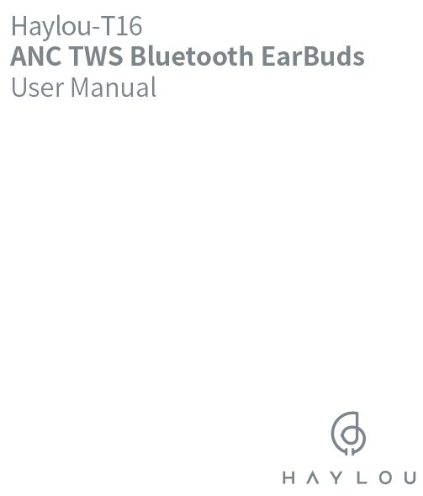
Haylou-T16 ANC TWS Bluetooth EarBuds User Manual
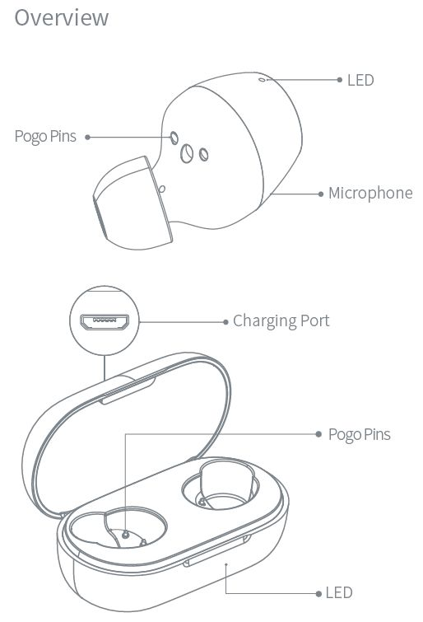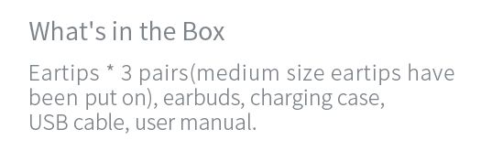
What’s in the Haylou T16 Package
Eartips * 3 pairs(medium size eartips have been put on), earbuds, charging case,
USB cable, user manual

Haylou T16 Pairing

How to Pairing Haylou T16
- Auto connection: Take up two Haylou T16 earbuds from the case, they will auto power on and pair with each other in 3s (right earbud Will serve as master as the default)
- Open Bluetooth on cellphone, When LED blinks slowly, search for Haylou-T16 R/L on phone and tap to connect.
- If Connect steps success, Haylou T16 Pairing complete!
- If earbuds fail to connect to phone, please pop them back into case and repeat the above steps Earbuds Will auto reconnect to the last device in connectivity records) if any. ( Bluetooth faculty needs to be activated )
Note: T16 has been set to factory before shipping out
LED glows White for 15
Haylou T16_R
Manual pairing: power off earbuds then manually power on them again. Earbuds Will auto enter TWS pairing mode(LED blinks white promptly)
and finish pairing when LED on master earbud blinks White slowly. On cellphone, search the earbuds and tap to connect,
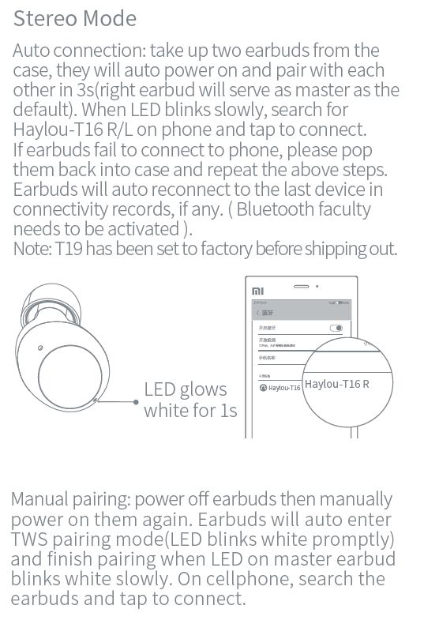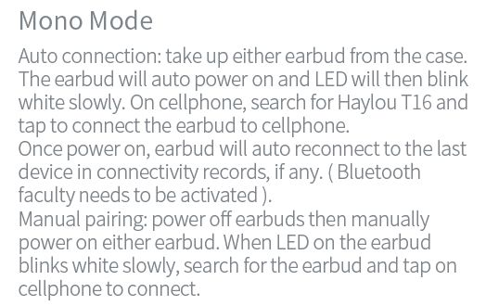
Haylou T16 Mono Mode
Auto connection: take up either earbud from the case.
The earbud will auto power on and LED will then blink white slowly. On cellphone, search for Haylou T16 and tap to connect the earbud to cellphone.
Once power on, earbud will auto reconnect to the last device in connectivity records, if any. ( Bluetooth faculty needs to be activated ).
Manual pairing: power off earbuds then manually power on either earbud. When LED on the earbud blinks white slowly, search for the earbud and tap on
cellphone to connect.

Haylou T16 Reset

How to Reset Haylou T16
Factory Setting – If earbuds do not function well, please refer the following steps to reset factory:
- Push earbuds back into the case power off two Earbuds first before Reset Haylou T16;
- open the lid and triple click the case to set them to factory;
- Delete the Bluetooth record on cellphone
- Earbuds will then auto pair with each other A Right earbud Will serve as master and become connectable to cellphone when LED blinks white slowly (If earbuds stay in the case, they will only be charged after pairing With each other)
- Audio only outputs from single earbud
- It’s really rare. Please reset Haylou T16, remove connectivity record on your cellphone and reconnect the earphones to your cellphone.
Other cases in charging
LED glows solid white for 1 minute when earbuds are topped up.
Carry case cannot charge earbuds, if its battery drains.
LEDs on carry case will turn off once the case is topped up. If you charge it once again, LEDs will not give any notice, which does not mean the case is not charged.
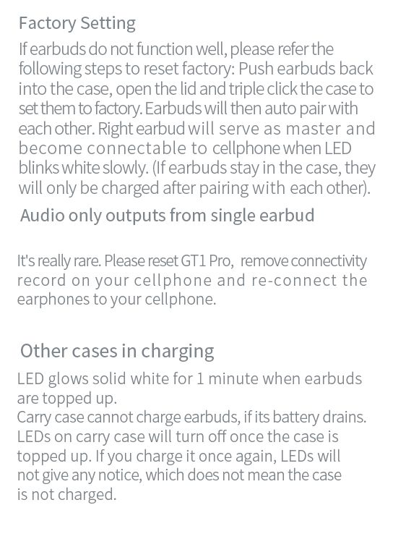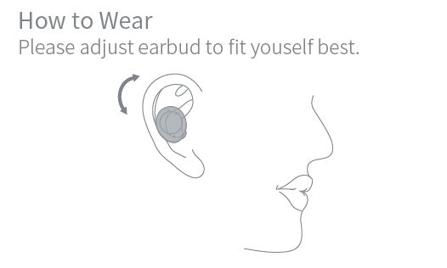

Haylou T16 How to Wear

Haylou T16 How to Use
- Please adjust earbud to fit yourself best
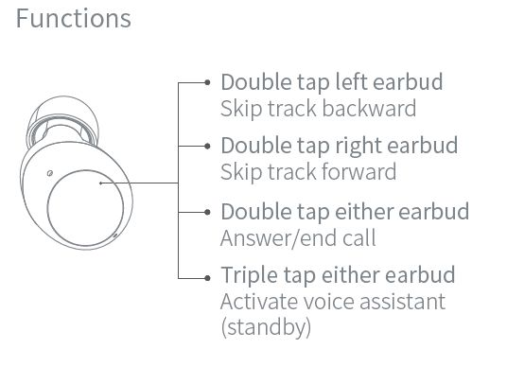

Haylou T16 Touch Control
- Skip track backward: Double tap left earbud
- Skip track forward: Double tap right earbud
- Answer/end call: Double tap either earbud
- Activate voice assistant (Standby): Triple tap either earbud

Haylou T16 Volume Control
- Haylou T16 Volume Control not support , please control volume by adjusted on cellphone
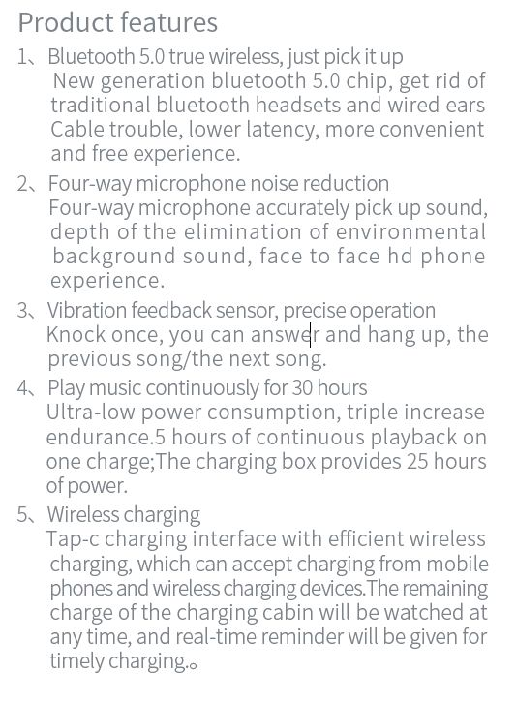
Haylou T16 Features
- Bluetooth 5.0 true wireless,just pick it up
- New generation Bluetooth 5.0 chip, get rid of traditional Bluetooth headsets and wired ears Cable trouble, lower latency, more convenient and free experience,
- Four way microphone noise reduction
- Fourway microphone accurately pick up sound, depth ofthe elimination of environmental background sound, face to face hd phone experience.
- Vibration feedback sensor, precise operation Knock once, you can answdr and hang up, the previous song/the next song.
- Play music continuously for 30 hours
- Ultra Alow power consumption, triple increase endurance AS hours of continuous playback on one charge; The charging box provides 25 hours
of power.
- Wireless charging
- Tap-c charging interface with efficient wireless charging, which can accept charging from mobile phones and wireless charging devices. The remaining
charge of the charging cabin will be watched at any time, and real~time reminder will be given for timely charging.
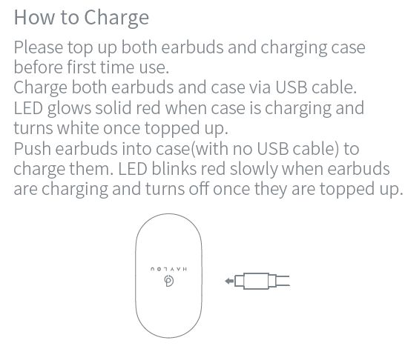
How to Charge

Haylou T16 Charging Case
- Please top up both earbuds and charging case before first time use
- Charge both earbuds and case via USB cables
- LED glows solid red when case is charging and
turns white once topped up.

Haylou T16 Charging Earbuds
- Push earbuds into case(with no USB cable) to charge them LED blinks red slowly when earbuds are charging and turns off once they are topped up.
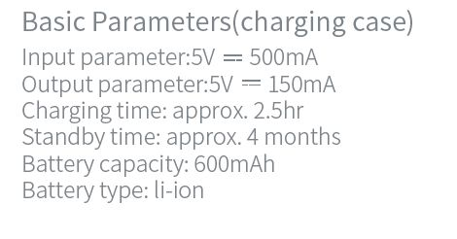
Haylou T16 Parameters(charging case)
- Input parameter:5V = 500mA
- Output parameter:5V = 150mA
- Charging time: approx. 2A5hr
- Standby time: approx. 4 months
- Battery capacity: 1600mAh
- Battery type: li-ion
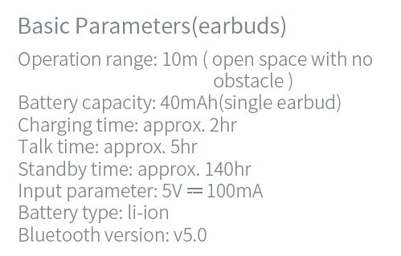
Haylou T16 Parameters (earbuds)
- Operation range: 10m ( open space with no obstacle)
- Battery capacity: 40mAh(single earbud)
- Charging time: approx. 2hr
- Talk time: approx. 5hr
- Standby time: approx. 140hr
- Input parameter: 5v = l00mA
- Battery type: li-ion
- Bluetooth version:v5.0
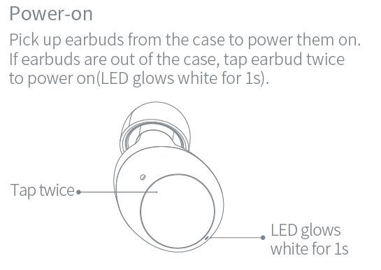

Haylou T16 Power on
- Pick up earbuds from the case to power them on
- If earbuds are out of the case, tap earbud twice to poweron(LED glows White for ls)
Tap twice
LED glows White for 1s
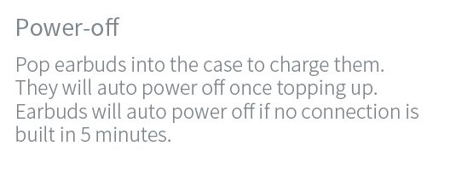

Haylou T16 Power off
- Pop earbuds into the case to charge them
- They will auto poweroff once topping up
- Earbuds will auto power offif no connection is built in 5 minutes
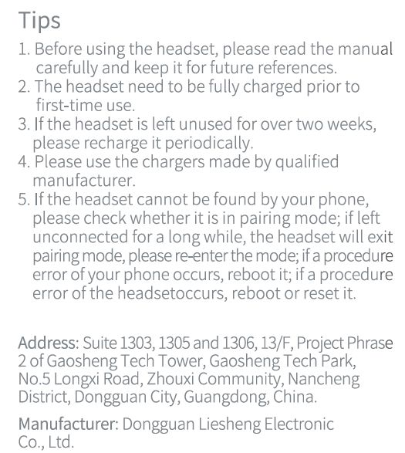
Haylou T16 Tips
- Before using the headset, please read the manual carefully and keep it for future references.
- The headset need to be fully charged priort. first—time use.
- Ifthe headset is left unused for over two weeks, please recharge it periodically,
- Please use the chargers made by qualmed manufacturer.
- Ifthe headset cannot be found by your phone, please check whether it is m pairing mode; if left unconnected fora longwhile, the headset will exit pairing mode, please re-enterthe mode; If a procedure error of your phone occurs, reboot it; if a procedure error of the headset occurs, reboot or reset It.
Address: Suite 1303, 1305 and 1306,13/F, Project Phrase
2 of Gaosheng Tech Tower, Gaosheng Tech Park,
Noo5 Longxi Road, Zhouxi Community, Nancheng
District, Dongguan Clty, Guangdong, China.
Manufacturer: Dongguan Liesheng Electromc
Co , Ltd.
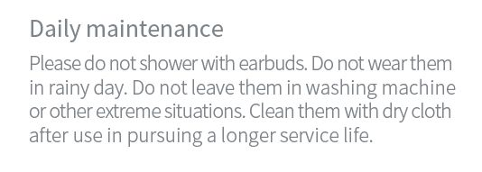
Haylou T16 Daily maintenance
- Please do not shower with earbuds. Do not wear them in rainy day. Do not leave them in washing machine or other extreme situations, Clean them with dry cloth after use in pursuing a longer service life.
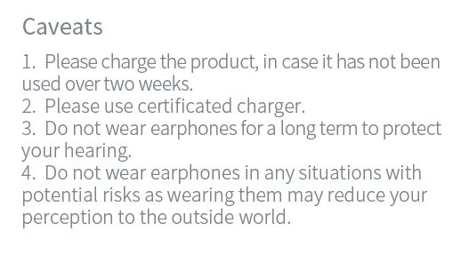
Haylou T16 Caveats
- 1. Please charge the product, in case it has not been
used overtwo weeks.
- 2. Please use certificated charger.
- 3. Do not wear earphones for a long term to protect
your hearing
- 4. Do not wear earphones in any situations with
potential risks as wearing them may red uce your
perception to the outside world.
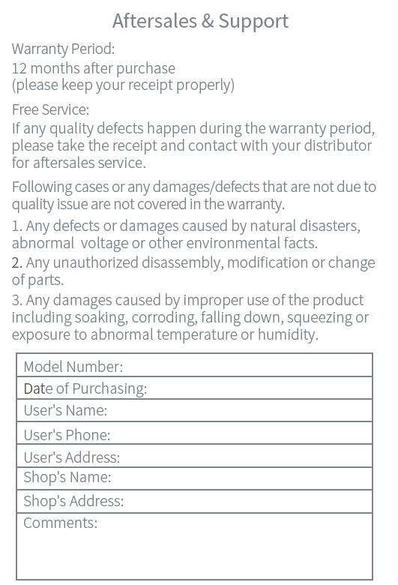
Aftersales & Support

Haylou T16 Warranty Period:
- 12 months after purchase
(please keep your receipt properly)
- Free Service:
If any quality defects happen during the warranty period, please take the receipt and contact with your distributor for aftersales service.
Followingcases or any damages/defects that are not due to
quality issue are not covered in the warranty.
- Any defects or damages caused by natural disasters, abnormal voltage or other environmental facts.
- Any unauthorized disassembly, modification or change of parts.
- Any damages caused by improper use of the product including soaking, corroding, falling down, squeezing or exposure to abnormal temperature or humidity.
Model Number:
Date of Purchasing:
User’s Name:
User’s Phone:
User’s Address:
Shop’s Name:
Shop’s Address:
Comments:
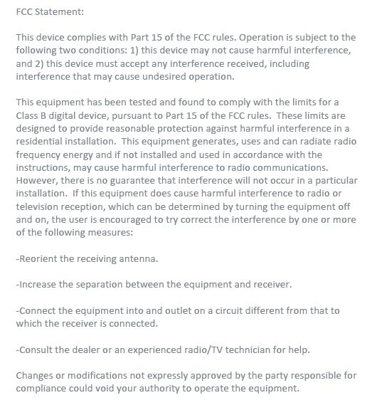
Haylou T16 FCC Statement:
This device camplies with Part 15 of the FCC rules. Operation ls subjuct to the
following two conditions: 1) (This device may not cause harmful lnterference,
and 2) This device must accept any interference received, including
Interference that may cause undesired operation.
This equipment has been tested and found to comply with the limits for 3
class; B digital device, pursuant to part 15 of the Fcc These Limits are
designed to provide reasonable protection againse harmful interference in a
residential install. This equipment generates, uses and can radiate radio
frequency energy and if not installed and used in accardance with the
instructions, may cause harmful interference to radio communications.
However,there1s no guarantee that lnterference will not occur m z particular
lnstall. if This equipment does cause harmful interference to radio or
(television reception, which can he determined by turning the equitment! off
and on, the user is encouraged to try correct the Interference by one or more
of the following measures:
Reorient the receiving antenna:
Increase the separation between the equipment and receiver
Connect the equipment into and outlet on a circuit different from that to which the receiver is connected
Consult the dealer or an experinced radio / TV technician for help
Changes or modifications not expressly approved by the party responsible for compliance could void your autoority to operate the equipment
Changes nr mndxﬁcatlnns not expressly approved by the party responslble far
cnmpnanoe could vmd vnur zulhnnly m npemte the Equipment.
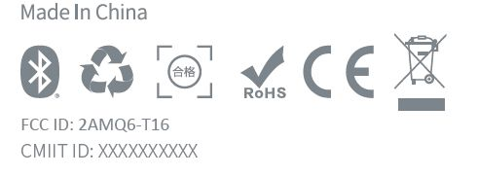
Madeln China
Haylou T16 FCC ID: ZAMQS—TIG
CMIIT ID: XXXXXXXXXX
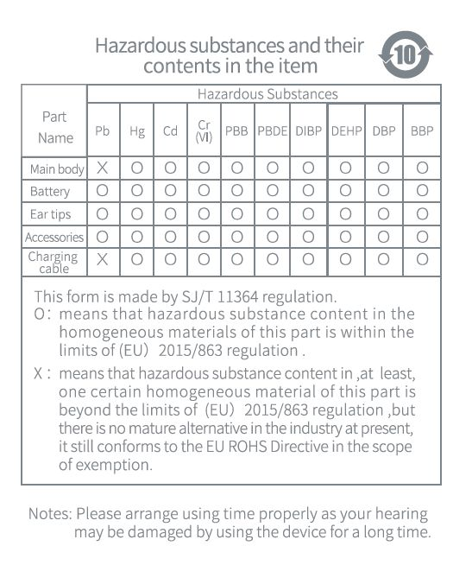
Haylou T16 Hazardous substances and their
contents in the item

